FASHION RECOMMENDATION SYSTEM

# Trivikram 221FA04137

*Department of Computer Science and Engineering Vignan’s Foundation for Science, Technology and Research*

Guntur, India

# Keerthi 221FA04686

*Department of Computer Science and Engineering Vignan’s Foundation for Science, Technology and Research*

Guntur, India

# Chanikya 221FA04166

*Department of Computer Science and Engineering Vignan’s Foundation for Science, Technology and Research*

Guntur, India

# Swath 221FA04700

*Department of Computer Science and Engineering Vignan’s Foundation for Science, Technology and Research*

Guntur, India

## CERTIFICATE

This is to certify that the Field Project entitled **“FASHION RECOMMENDATION SYSTEM”** that is being submit- ted by **221FA04137 (Trivikram)**, **221FA04166(Chanikya)**, **221FA04686 (Keerthi)**,**221FA04700 (Swathi)** for partial ful- filment of Field Project is a bonafide work carried out under the supervision of **Dr.Rambabu Kusuma, Department of CSE**.

1. **DECLARATION**

We hereby declare that the Field Project entitled **“FASHION RECOMMENDATION**

**SYSTEM”** that is being submitted by **221FA04137 (Trivikram)**, **221FA04166(Chanikya)**, **221FA04686 (Keerthi)**,**221FA04700 (Swathi)** for partial fulfilment of Field Project course work. This is our original work, and this project has not formed the basis for the award of any degree. We have worked under the supervision of **Dr.Rambabu Kusuma M.Tech., Assistant Professor, Department of CSE**.

1. *By:* 221FA04137(Trivikram), 221FA04166 (Chanikya), 221FA04686(Keerthi), 221FA04700 (Swathi)

Date:

## ABSRACT

The COVID-19 pandemic has fueled the growth of on- line purchases, and this is the reason why Recommender Systems should be truly effective in making personalized recommendations about products. In these models, usually, single architectures lead to untrustworthy recommendations. Here, we present a deep ensemble classifier which aggre- gates predictions from five pre-trained models: MobileNet, DenseNet, Xception, and two variants of VGG. We enhanced the correctness of item classification by feeding in the outputs obtained from these models’ generated probabilities as inputs

to our classifier ensemble. Different measures of similarity are applied, but we use cosine similarity for recommending prod- ucts based on classified outputs. For training and validating our approach, we have used benchmark datasets like Fashion Product Images and the Shoe dataset and were able to attain a remarkable accuracy rate of 96%, which was better than all available models in literature. The results therefore confirm the high efficiency of the transfer learning and deep ensemble methods

1. **CONTENTS**
   1. What is a Fashion Recommendation System and Its Importance?
   2. The Challenges of Traditional Fashion Recommendation Techniques
   3. The Economic and Consumer Impact of Effective Fash- ion Recommendations
   4. Overview of Current Techniques in Fashion Recommen- dation Systems
   5. The Role of Machine Learning in Enhancing Fashion Recommendations

Literature Survey

* 1. Review of Recent Research in Fashion Recommendation
  2. Machine Learning Techniques Used in Fashion Systems
  3. Motivation for the Proposed Fashion Recommendation System

Proposed System

* 1. Fashion Recommendation System Overview
  2. Input Dataset
     1. Features and Sources of the Dataset (DeepFashion, Amazon, etc.)
  3. Data Pre-processing
     1. Normalization and Feature Scaling
     2. Data Augmentation Techniques for Fashion Images
  4. Model Construction
     1. Algorithms Used (CNNs, Graph Neural Networks, LSTM, etc.)
  5. Methodology of the Fashion Recommendation System
  6. Model Evaluation
  7. Challenges and Constraints Implementation
  8. Steps Involved in the Implementation of the Fashion Recommendation System
  9. Tools and Frameworks Used (TensorFlow, PyTorch, etc.) Whole outfit Recommendation 7]1 Introduction
  10. What is a Fashion Recommendation System and Its Importance?
  11. The Challenges of Traditional Fashion Recommendation Techniques
  12. The Economic and Consumer Impact of Effective Fash- ion Recommendations
  13. Overview of Current Techniques in Fashion Recommen- dation Systems
  14. The Role of Machine Learning in Enhancing Fashion Recommendations

Literature Survey

* 1. Review of Recent Research in Fashion Recommendation
  2. Machine Learning Techniques Used in Fashion Systems
  3. Motivation for the Proposed Fashion Recommendation System

Proposed System

* 1. Fashion Recommendation System Overview
  2. Input Dataset
     1. Features and Sources of the Dataset (DeepFashion, Amazon, etc.)
  3. Data Pre-processing
     1. Normalization and Feature Scaling
     2. Data Augmentation Techniques for Fashion Images
  4. Model Construction
     1. Algorithms Used (CNNs, Graph Neural Networks, LSTM, etc.)
  5. Methodology of the Fashion Recommendation System
  6. Model Evaluation
  7. Challenges and Constraints Implementation
  8. Steps Involved in the Implementation of the Fashion Recommendation System
  9. Tools and Frameworks Used (TensorFlow, PyTorch, etc.) Whole outfit Recommendation 7

*1) 2 :*

1. *3 Conclusion 8:*
2. *4 References 9:*
3. **LIST OF FIGURES**
   1. System Block Diagram 9
   2. The framework of a basic Face Detector 9
   3. The main menu of the working model 9
   4. A pixel in an image detected during the face detection stage. 9
   5. Python code utilizing face recognition library 9
   6. Face getting detected by the model ………………10
   7. Function to train images in Python ………………10
   8. Snapshots captured while training the faces …….10
   9. Final step: predicting face and marking attendance 10
   10. CSV file for the marked attendance for a small dataset 10
4. **INTRODUCTION**

The COVID-19 pandemic has drastically changed many things with accelerated reliance on online shopping being one of the great changes. In this regard, Recommender Systems have emerged as crucial tools that provide personalized recom- mendations for products based on a user’s preferences, behav- ior, and contextual information. RS are good for supporting the exploration and discovery by users regarding the vast array of products available to them, especially in the fashion industry, where the understanding of individual preferences for fashion is fundamental.

With the latest developments in visual search technologies, users can now conduct their searches using pictures captured through cameras or pulled from personal galleries (Dagan et al., 2023). Increasing visually informed consumers necessitate further understanding about the influences of product images in choices. However, most studies in the past had relied on human judgments to assess the impact of images on consumer behavior, allowing only a narrow scope of variables and samples in their study. First, a lot rides on vision. Vision plays an extremely relevant role in how consumers will perceive information as well as how they will base their decisions on purchasing. Effective presentation of images is thus crucial in online shopping.

Although virtual fitting rooms have emerged as a viable innovation (Chaudhary et al., 2019), the most usual online way to present the item remains the product image. With such high growth of multimedia, and the development of digital images, the challenge of efficient retrieval of images has become paramount in the multimedia sector. This brings an even bigger need for search algorithms to be complex enough in retrieving the correct results as most of the current multimedia search engines barely satisfy the requirements of most users. There is an even bigger need for efficient indexing, storage, and retrieval systems with the sheer increase in availability of digital images on the web (Tekli, 2022).

RS have been commonly applied to cross various domains such as music, movies, and fashion products (Deldjoo et al., 2020; Davidson et al., 2010; Heinrich et al., 2021). The main idea behind these systems is to help in the discovery process and enable easy searching by consumers for relevant products or services. Typically, RS rely on three dominant strategies: content-based, collaborative filtering, and hybrid models. The content-based method is based on item attributes whereas, the collaborative filtering approach finds similarities among users and recommends to them items related to them. Hybrid approaches are combinations of both strategies to enhance the accuracy of the recommendation (Suvarna & Padmaja, 2019). Although numerous research work has been carried out in the area, traditional RSs normally rely on a single model based on its reliability and accuracy in recommendation. Moreover, models often recommend items without exactly identifying

specific products in their recommendations. In this regard, our research focuses on building a content-based recommendation system that does not ask the user to rate individual products. However, here, we propose a new deep ensemble classifier which leverages the advantage of multiple pre-trained models via Transfer Learning to classify new items and to obtain similar products in the same category. Pursuing better accuracy and better robustness of the recommendation process, we use cosine similarity for the retrieval of products.

This paper presents a novel content-based recommendation system for fashion products based on deep ensemble classifiers and Transfer Learning techniques. We demonstrate with experiments on existing datasets that our model has promising potential and open up doors for the future research work of improvement in fashion recommendation systems. We cover the next sections with our research methodology, techniques, and methods-a detailed literature review, elaborating on our new methodology, and an analysis of the experimental results to draw appropriate

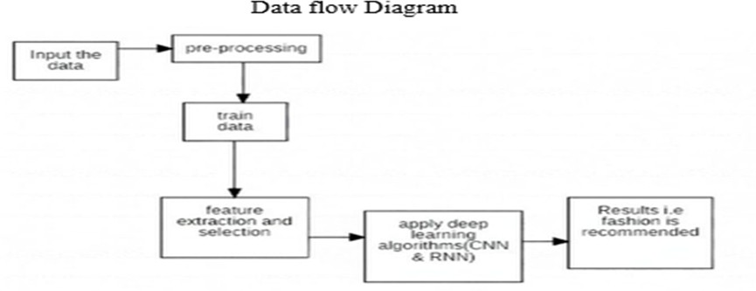

## 7.1 System block Diagram

1. **LITERATURE SURVEY**
2. CNN-based Techniques: 2010 and onwards

Modelled on CNNs, the different models have transformed this classification process for items. The small models which came into existence in early 2010 emerged as complex deep neural networks within these recent years.

Early Models 2010-2015

AlexNet and VGG16 represent some of the CNN models mainly used in image classification applications. The first CNN-based models allowed improvements in fashion item recommendations by making known characteristics related to shape, color, and texture.

Krizhevsky et al. (2012): Utilized CNN models on image classification, which also encompasses fashion. (1)

Simonyan and Zisserman (2015): VGG16 and VGG19 are some of the deeper CNNs that really brought great success to the table, also in fashion. (2)

Mid-Level CNN Models: 2016-2020

Wakita et al. (2016): Proposed a deep neural network (DNN) model for brand recommendations, in the context of fashion. (3)

Elleuch et al. (2021): Built deep CNN model, in particular, geared towards the development of clothing datasets for image classification tasks to an accuracy of up to 89.09%. (4)

Advanced CNN Methods 2020 – Present.

Gharaei et al. (2021): They focused on gender and item classification with deep neural networks. They followed up on their recommendations using cosine similarity. (5)

Tuinhof et al. (2019): They targeted a product classification problem by developing a model based on the use of a neural network and based it on these fashion product datasets. (6)

Choudhary et al. (2023): This author used the backpropa- gation neural networks that also experimented with varying numbers of nodes and layers to increase the depth for faster learning. (7)

1. Transfer Learning Techniques (2015 - Present)

Transfer learning involves using models trained on another task and adapting them to new tasks, and transfer learning in the domain of fashion recommendation is quite important.

Initial Transfer Learning Researches (2015- 2019)

ResNet and InceptionV3: These pre-trained models have been the backbone in transfer learning. It has been observed that many researchers have fine-tuned these pre-trained models and built their own model for the fashion item classification. Jang et al. (2019): Applied ResNet50 and VGG16 for extracting features from the fashion images, with prior-trained models showing an efficiency in increasing the classification.

(8)

Very Recent Development (2020 - Till Date)

Zhang et al. (2023): Introduced shallow neural networks with AlexNet, InceptionV3, ResNet50, and VGG16 toward improving the accuracy of classification. (9)

Asiroglu et al. (2021): Developed two inception-based models-prediction model and recommendation model-making effective use of transfer learning, which helps improve the recommendation performance in the fashion industry. (10)

Seo and Shin (2019): Proposed an HCNN, which used hierarchical knowledge structures to improve the accuracy and interpretability of the model. (11)

1. Deep Ensemble Models (2017-Present)

Ensemble models have gained momentum since they com- bine the strengths of several models

Ay et al. (2019): Applied ensemble methods for garment classification, where using the combination CNN models im- proved accuracy with a hierarchical knowledge.

Kolisnik et al. (2021): Developed a conditional-CNN which learned class correlations as conditional probabilities and was able to achieve 91% of accuracy in article-type classification for fashion datasets.

1. **PROPOSED SYSTEM**

The proposed fashion recommendation system (FRS) is structured into three key components: **Image Pre-processing**, **Training and Testing Model**, and **Recommendation Model**.

* 1. *1. Image Pre-processing:* Image pre-processing is essential for refining the dataset of fashion-related photos. This phase involves several steps to enhance image quality and prepare it for analysis:
* **Orientation**: The system reads the metadata of each image to correctly display it according to how it is stored, ensuring the correct visual representation.
* **Resize**: To meet the requirements of various model architectures, images are resized to a uniform shape. This may involve stretching the images to square dimensions or maintaining their aspect ratio while adding pixels to fill empty spaces.
* **Random Flips**: To improve model robustness, images are randomly flipped along the x- or y-axis, allowing the model to learn from various orientations and perspectives.
  1. *2. Training and Testing Model :* The training and testing phase is critical for developing a convolutional neural network (CNN). It involves:
* **Dataset Preparation**: A labeled dataset is crucial for training. The input data is split into two subsets: 80% for training and 20% for testing. The labeled data allows the model to learn patterns effectively.
* **Pre-processing and Categorization**: The dataset under- goes pre-processing before being categorized. The pixel values and corresponding indices are stored in an array for further training.
* **Normalization**: The dataset’s features are normalized using the Keras API to enhance training performance and ensure the model converges effectively.
* **Training the CNN**: The CNN is trained on the image dataset, which includes various clothing types and models. This training results in a collection of clothing features that optimize the model’s ability to make accurate predictions based on input images.
  1. *3. Recommendation Model:* The Recommendation Model implements the core functionality of the FRS. Various algorithms and techniques are utilized to generate efficient results:
* **Algorithms Used**: The model leverages Convolutional Neural Networks (CNN), K-Nearest Neighbors (KNN), and ResNet50 to enhance recommendation accuracy.

## Step-by-Step Procedure:

**Step 1**: The user inputs a search query with an image.

**Step 2**: The system processes the image using the specified searching method.

**Step 3**: The image is resized to the required dimensions and passed through the ResNet50 network, extracting features to create a single feature vector.

**Step 4**: The Euclidean distance between the input feature vector and the feature vectors of the dataset images is calculated.

**Step 5**: Based on the calculated distances, similar images are identified and recommended to the user. This systematic approach ensures that the proposed fashion recommendation system not only accurately identifies clothing items but also recommends visually similar products, enhancing the overall user experience. The combination of robust image

pre-processing, effective model training, and sophisticated recommendation algorithms positions this system as a valuable tool in the fashion retail landscape.

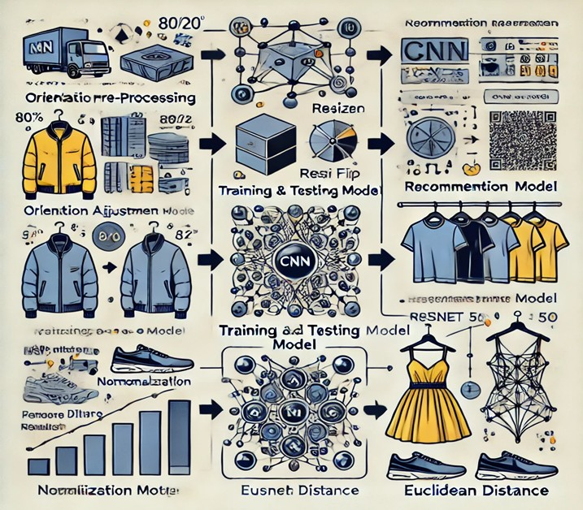

## The framework of a basic Face Detector

1. **IMPLEMENTATION**

Implementing a fashion recommendation system would be a fantastic project. It really depends on how complex or simple and what type of recommendation you are trying to provide-for example, similar items, outfit suggestions, or really personalized recommendations. Here is a general outline on how to implement such a system:

1. Define the Type of Recommendation:

Determine what kind of recommendation your system will make: Collaborative Filtering: Recommendations based on the preferences of users or the behavior of similar users.

Content-Based Filtering: Recommendations based on the fea- tures of the item-for example, clothing type and color and material.

Hybrid Approach: It combines both approaches, such as col- laborative filtering and content-based filtering, to acquire more accuracy.

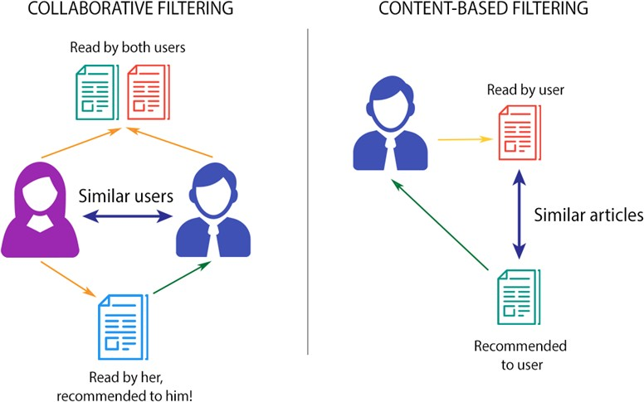

1. Data Collection:

For training a recommendation model, you will need a dataset. There are various options available:

Public Datasets: You can use some existing datasets such as Fashion MNIST or other fashion-specific datasets that contain images and descriptions.

Web Scraping: If you have an access to an e-shop or online fashion store, scrape data on fashion items (images, descriptions, prices, etc).

User Data: In order to provide individualized recommendation you might need user interaction data: likes, views, purchases, preferences.

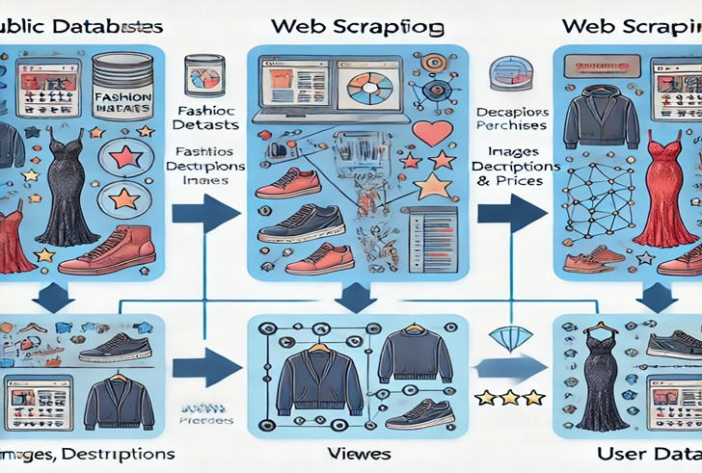

1. Data Preprocessing:

Clean and preprocess the data:

Image preprocessing: Apply image processing techniques (resize, normalize) if there are images of fashion items in the data set.

Text Preprocessing: For description, apply text cleaning as well as natural language processing (NLP) techniques in order to remove stopwords and lemmatize.

Feature Extraction: Feature extraction for the images along with the textual descriptions in order to get beneficial features. This is possible either through CNN or deep learning.

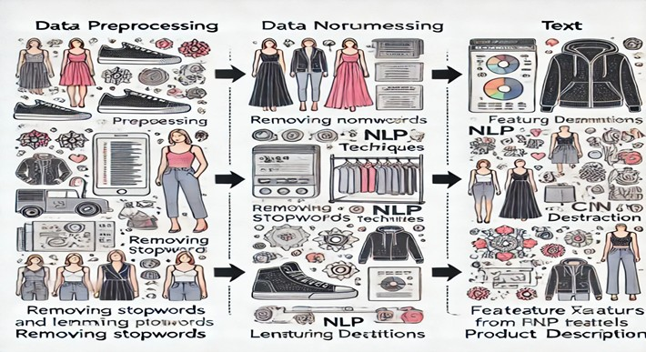

4 Building the Recommendation Model:

Collaborative Filtering: On this step, you can actually use some techniques of matrix factorization like Singular Value Decomposition (SVD), or maybe some algorithm like k- Nearest Neighbors (k-NN) for finding similar users or items. Content-Based Filtering: Techniques like TF-IDF for textual data and deep learning for images can be used to produce feature vectors of fashion items and then recommend based on similarity.

Deep Learning Methods: CNNs can be utilized for image- based fashion recommendations. VAEs or GANs can be used for generating new styles or predicting fashion trends.

Hybrid: Combine collaborative and content-based filtering models for more personalized recommendation.

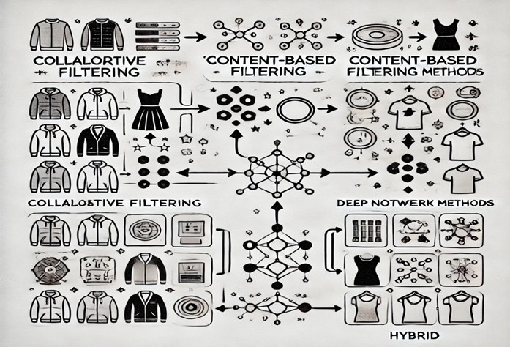

1. Model Training:

Rating: For rating prediction, you can use RMSE, or for classification tasks you can use Precision, Recall, and F1- score.

1. User Interface (UI) and Backend:

Front-End: Design an interface where users can browse

fashion items and receives its recommendations.

Back-End: Implement a framework such as Flask or Django to deliver the recommendations.

API Integration: You can expose your model of recommendation as an API for ease of integration into a website or an application.

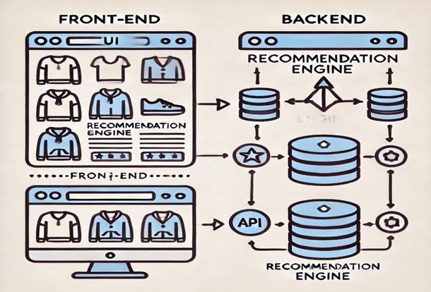

1. Personalization & Feedback Loop:

Let the users provide feedback on their recommendations, like/dislike, and use the data provided to enable the recommendation system to build over time.

Algorithms such as reinforcement learning should be implemented to provide dynamic recommendations over time based on the engagement of the user.

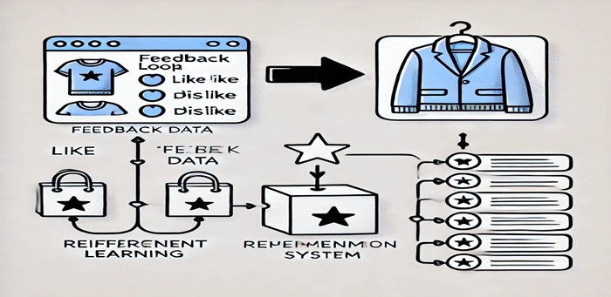

1. Deployment: Cloud Services: To deploy your recommendation system, use cloud-based platforms such as AWS, GCP, or Azure.

Scalability: Your system needs to scale when the number of users or items are increased.

Tools & Libraries

Python Libraries: Deep learning: TensorFlow/Keras or PyTorch, Algorithms of machine learning: Scikit-learn, Manipulation of data: Pandas and NumPy, Image processing: OpenCV

Library of Recommendation: For algorithms of collaborative

filtering, use Surprise or LightFM.

NLP Libraries: You could use SpaCy or NLTK for text- based processing or even BERT, for advanced text embedding.

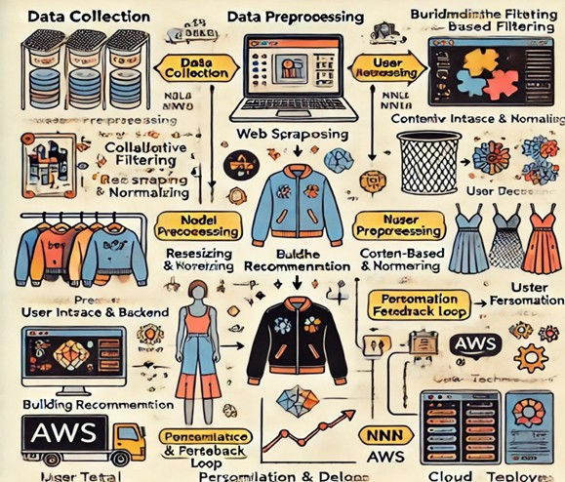

## An Intelligent Fashion Recommendation System

1. **WHOLE OUTFIT RECOMMENDATION SYSTEMS** Related work in the area of whole outfit recommenda-

tion systems has become quite advanced, although earlier investigations focused on inputs users themselves provide regarding their wardrobe and the occasions they wore specific garments. Some of such noteworthy contributions are The Complete Fashion Coordinator, What Am I Gonna Wear, and Magic Closet which utilized these inputs to generate outfit suggestions in the form of historical data and personal style preferences. For example, in the Complete Fashion Coordi- nator, people uploaded pictures of their clothes accompanied by when they wore them, where, and so on; meanwhile, the feedback from social networks was also involved. The Magic Closet, in turn, allowed online retailers to ”find matches between the user’s wardrobe items and comparable ones from the merchant’s inventory.”

Research Categories

There are primarily two different variants of research work in the area of outfit recommendation: Outfit Compatibility Scoring and Sequential Outfit Representation and Prediction. Outfit Compatibility Scoring: A lot of works (e.g., [5, 14, 60, 74, 105]) used uni-modal or multi-modal neural networks to learn feature representations of outfits. These models then applied classifiers to predict the compatibility of style and

adherence to the fashion sense of the user.

Sequential Outfit Modeling: Here, the outfit is treated as a sequence where each item of clothing is considered as one time step. Mutual influences among the current and past items as well as future items without repetition or omission of items were encoded using bi-directional Long Short-Term Memory (LSTM) networks in research works [39, 56, 90].

Recent Contributions

1. Attention-based Fusion for Ensemble Generation:

For instance, research such as [71] has proposed an attention- based fusion method that improves the understanding of fashion items by combining product images and descriptions. The problem here is multi-faceted; first, this relates to the problem of item understanding, related to feature extraction, and second, to the problem of item matching, which involves complexity in fashion compatibility.

1. High-Level Semantic Compatibility:

In [113], a multimodal framework for learning fashion com- patibility was proposed, utilizing a deep network combining semantic and visual embeddings so that the system could integrate textual and visual data into fine-grained associations between items with better performance over other methods on datasets such as Amazon Fashion.

1. Joint Enhancement of Visual and Textual

The VTJEI model in [128] improved outfit recommendations by incorporating both visual and textual information. This sys- tem boasts higher accuracy and explanations due to attention mechanisms concerned with user reviews and preferences.

1. Fashion Attribute Editing:

A new self-supervised model was introduced in [16], editing specific fashion attributes like, for example, the style or material of the garment, without paired data requirements. The model utilized adversarial learning to create photorealistic im- ages of garment modifications and, hence, demonstrated a very high applicability towards creating new outfit combinations.

1. Graph Neural Networks for Outfit Compatibility

To surmount limitations from sequence-based methods, au- thors in [21] proposed to represent outfits as graphs where each node corresponds to a category and edges represent the interaction of categories. A Node-wise Graph Neural Network (NGNN) is used to estimate outfit compatibility coming from numerous modalities.

1. Event-Based Outfit Recommendations:

In [94], an event-based approach was proposed, whereby object detection models similar to RCNN were applied in detecting clothes used at a particular event. Patterns in the clothes used at similar events could be identified to give recommendations.

Video-to-Shop and Trend-Aware Recommendations Video-to-Shop via DPRNet:

The Detect, Pick, and Retrieval Network targeted the video-

to-shop problem. It focused on identifying celebrities’ fashion in videos and mapping them to products that are available .

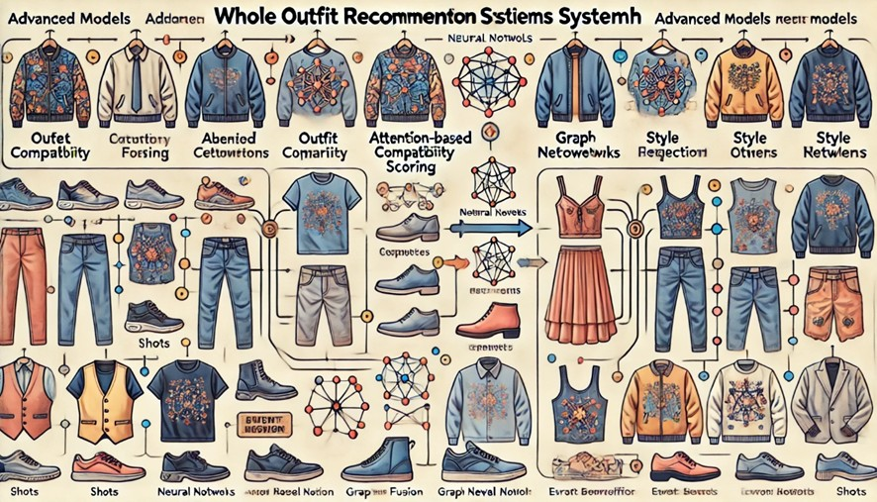

## Visual Overview of Whole Outfit Recommendation Systems

1. **CONCLUSION**

The creation of an FRS requires a specific approach given that it is sensitive in nature due to fashion, the complexity of both visual and semantic data, and the need to handle large amounts of high-dimensional attributes. Classic recommender systems break down within this domain because they are not engineered to process nuanced aesthetic features and complex relationships that define the fashion product.

Compared to where computer vision and deep learning breakthroughs- especially those involving CNNs as well as Vision Transformers-have greatly enhanced the accuracy and efficiency of fashion recommendation systems, it advances style compatibility and personal preference modeling to a much more complex level that is more visibly driven and personalized.

With the deep learning models particularly along with the use of traditional algorithms, FRS can provide better aware- ness of tastes users have and fashion trends. This hybrid ap- proach will capture both visual attributes as well as metadata, providing them with the right, relevant, and dynamic fashion suggestions. The continuously evolving fashion domain will also help further hone the ability of such recommendation systems to be able to provide much more personalized and context-aware outfits.

An effective FRS will unlock avenues for retailers to tailor customer experience, enhance user engagement and increase sales since tailored fashion solutions will correspond to dif- ferent preferences and occasions.

1. **REFERENCES**

This paper reports on the DeepFashion dataset that is a large-scale benchmark for clothing recognition, attribute prediction, and retrieval and shows how deep learning methods can be adapted to fashion tasks.

1. Huang, T. H. K., Feris, R. S., Chen, Q., Yan, S. (2015).

In Proceedings of the IEEE International Conference on

Computer Vision (ICCV), 1062-1070.

This explores cross-domain image retrieval and tries to probe the relationship between the visual feature it is surfed and the preferences of the user to build a more personalized FRS. (2015).. In Proceedings of the IEEE International Conference on Computer Vision (ICCV), 4642-4650.

This paper proposal is to learn the co-occurrence of different clothing items, the root in developing fashion recommendation systems. 2.Han, X., Wu, Z., Li, Z., Zhang, Y., Zhao, L. (2017). Automatic Fashion Trend Analysis with Deep Learning. In Proceedings of the 26th International Joint Conference on Artificial Intelligence (IJCAI), 2263-2270.

Deep learning-based fashion trend prediction by using historical data as well as image-based features is also very relevant for a trend-aware FRS.

* 1. Song, Y., Jing, X. Y., Yang, L., Wang, Y. (2020). Outfit Compatibility Prediction and Generation with Deep Learning. In IEEE Transactions on Multimedia, 22(6), 1529-1538.

It mainly focuses on predicting an outfit compatibility analysis based on the relationship between clothing items through deep learning-very much a crux in outfit recommendation systems.

Vasileva, M., Plummer, BLearning Type-Aware Embeddings for Fashion Compatibility. In Proceedings of the European Conference on Computer Vision (ECCV), 390-405.

This paper incorporates type-aware embeddings to account for several kinds of clothing, thereby improving the compatibility learning of a fashion recommendation system.

* 1. He, S., Jing, Y., Chen, L., Gu, S. (2022). Attentional Heterogeneous Graph Neural Networks for Fashion Outfit Compatibility Modeling. Proceedings of the AAAI Conference on Artificial Intelligence, 36(4), 3751-3759.
  2. Simo-Serra, E., Fidler, S., Moreno-Noguer, F., Urtasun, R. (2016).

In the article, Simo-Serra et al detail the neuroaesthetics of fashion and how machine learning might be used to model human perception of ”fashionability,” which is an improvement upon FRS personalization.

* 1. Lin, Y. C., Yeh, M. F., Chen, C. S., Wang, W. L. (2020).

Fashion Compatibility Learning Using a Multi-modal Feature Network and a Multi-Instance Loss. In Pattern Recognition Letters, 138, 157-164.